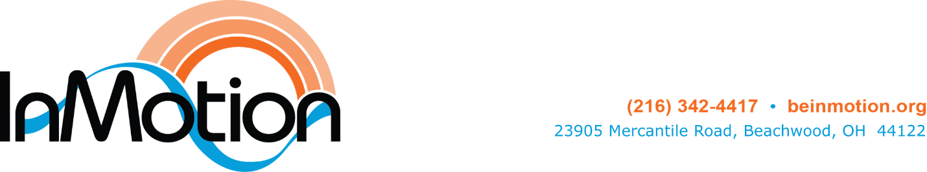
Position: Administrative Assistant
Reports to: Chief Operating Officer
Classification: non-exempt, 20 hours/week
Rate: $23 per hour

The Administrative Assistant (AA) supports the administrative team, 20 hours per week. The ideal candidate must be able to manage and complete multiple tasks in a fast-paced environment, be customer- and relationship-centered and able to communicate with a variety of stakeholders. Fluid management of projects assigned or proactively sought is critical. Must be able to anticipate needs, clear obstacles, and identify and take ownership of projects that need to be done.
Essential Job Functions
The AA will be responsible for providing clerical, data entry, and client support and assistance to the InMotion executive and program team. Specifically, this position will
Client Relations and Administration
- File and maintain general and program data and information for volunteers and clients
- Assist clients with class and assessment registration and communicate with clients regarding onboarding and assessments
- Communicate with clients regarding class cancellations, waitlists, etc.
- Enter attendance for off-site classes
- Assist with new client intake
- Ensure that clients are in the correct class for their color level
- Assemble materials for client and volunteer orientations
- Assist Program and Research Manager with inputting client assessment data and scores
General Administration
- Answer phone calls and reception emails and respond to information requests
- Maintain the “In The Know” board
- Update equipment and office inventory spreadsheet as needed
- Maintain stockroom inventory, including tracking and notifying COO when items need to be reordered
- Calculate volunteer hours
- Update collateral materials as needed
- Assist with mailings
- Send milestone event cards to board members and other special groups
- Provide backup for the reception desk
- Special projects and other tasks as assigned.
- Schedule meetings for the CEO
Qualifications
- Bachelor’s degree or a minimum of three years’ work experience
- Ability to connect with people from a variety of backgrounds
- Proficient in MS Office Word, Excel and Outlook
- Proven organizational skills
- Effective communications skills and a professional attitude
- Ability to prioritize work and manage multiple priorities
- Excellent project management skills
- Passion, idealism, integrity, positive attitude, mission driven and self-directed
- Demonstrated sensitivity and compassion for people with chronic disease
- Must possess the ability to lift, carry, push, and pull materials and objects weighing up to 25 pounds.
Skills
- Understanding of people, positive outlook and willingness to embrace InMotion’s mission
- Excellent written and verbal communication
- Ability to delegate and follow up on responsibilities in a timely fashion
- Highly organized with attention to detail in a fast-paced environment
- Strong interpersonal skills

InMotion
InMotion, a nonprofit organization located in Cleveland, OH, is a leader in community-based wellness programming for people with Parkinson’s disease. Since opening our doors in 2015, InMotion serves over 1,000 participants in Northeast Ohio. Our integrated and holistic wellness program is designed to complement the care our participants receive from their healthcare team in ways that address mind, body and spirit. InMotion is completely funded through donations from individuals, businesses, and foundations and offers its programs free of charge to people with Parkinson’s disease, eliminating the barrier of cost for the people it serves.
Submit a letter of interest and resume to: Kari Kreft, kkreft@beinmotion.org. No phone calls.

