CASE STUDY A

Boring Board Meeting Angers
Enthusiastic New Member

The two board members—one a veteran of seven years, the other a new appointee attending her first meeting—chatted amiably as they walked to their cars parked behind a grove of trees that shade the modest headquarters of the New England conservation group.

Pausing at her car, Susan Nickerson finally said, “Was this meeting typical of all board meetings, Sam?”

“I’m afraid so,” replied Samuel Schermerhorn.

Calculating her response carefully, Susan paused, frowned, then said the only word that seemed to fit what was in her head, “Boring.”

She continued: “I came to this meeting full of excitement, anxious to get to work, proud to have been asked to serve on the board because I believe its work with wetlands and natural conservancies is so vital. Then this: three hours of being talked to like I was a kid and being lectured at like I didn’t have a brain of my own. I was never given a chance to offer my opinion on anything. Neither was any other board member. And you say this is a typical meeting?”

“That’s right,” Sam replied. “It’s been this way for the last two years, ever since we got a new board chair. He’s a Casper Milquetoast and the chief executive, though low-key and not forceful, tends to dominate.”

“I began to get the picture during the meeting,” Susan said. “Our chair seems to be totally subservient to the executive. Does he want only a rubber-stamp board? The executive and staff do all the talking, and some don’t even know their subjects that well. I was so tired of hearing their monotonous voices I could have screamed. Just once I wanted someone to show some emotion. I would have even settled for a good slide show. You have no idea how bored I was. Our time was wasted.”
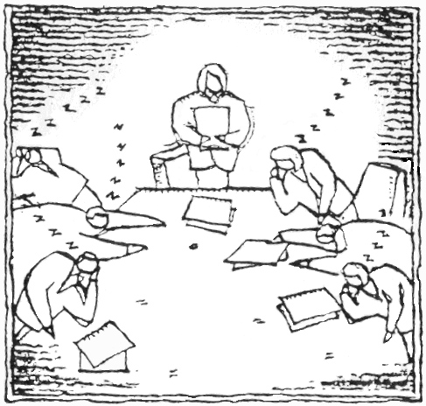

“That’s the way I’ve felt for a long time, but I’ve hung in there hoping things would get better,” Sam said, gazing downward.

“Sam, was this meeting boring and a waste of our time accidentally—or on purpose? In other words, is our executive trying to do a snow job on the board and keep us out of the decision-making loop? Or is the executive incapable of creating a meaningful agenda? Is the chair afraid to raise his voice and bang the gavel? Does either the executive or the chair care? Or is it because neither of them has any talent?”

“I really don’t think it’s devious,” Sam replied. “I think it’s the nature of the principal characters.”

“Hasn’t anybody on the board done anything about it?” Susan asked, climbing into her vehicle.

“No. I guess none of us wanted to rock the boat.”

“Well, I do,” Susan said, spinning gravel from all four wheels of her Range Rover.

What should Susan do?

